**Brand Perceptions of Traditional Products Pre-GI and Post GI**

Pranav Bhat1, a), Phani Kumar Pullela1, b), Sajjani Padmanabhan1, c), Rakshitha M1, d), Sumedha Vijayram Kumar1, e)

*1School of Computer Science Engineering (SOCSE), R V University, RV Vidyanikethan Post, 8th Mile, Mysuru Road, Bengaluru, 560059, Karnataka, India.*

*a)pranavbhat334@gmail.com*

*b)* [*phanikumarp@rvu.edu.in*](mailto:phanikumarp@rvu.edu.in)

*c)sajjanip.bsc22@rvu.edu.in*

*d)rakshitham.bsc22@rvu.edu.in*

*e)sumedhavk.bsc22@rvu.edu.in*

**Abstract.** This research paper looks into the evolution, profitability and marketing methods of Geographical Indications (GIs) and how they affect the branding of ordinary products before and after converting into GI. By contextualizing and legalizing GIs in the world, this work analyses how GIs work towards the protection of intangible cultural heritage everywhere in world. Some cases are also mentioned including Tuscany in Italy where Sorana Bean PGI aids in the generation of income for farmers which greatly compliments the economic effects Costa Rica to mention but a few. Furthermore, this paper introduces moving case studies such as Turkey where GIs are employed for the dual purpose of fostering rural growth and simultaneously marketing indigenous economic activities types up to Brazil, Moldova and so forth that proves helpful in cultural conservation ranging from comprehensive that also aids up.

***Keywords:*** *Geographical Indications (GIs), Traditional Products, Branding & Marketability, Economic Impact of GIs, Legal Framework & Regulations, Consumer Perception & Behaviour, Marketing Strategies for GIs, Export & International Market Access.*

**INTRODUCTION**

Geographical indications (GIs) are widely accepted tools for the protection of products originating from a certain region. They reveal their history, cultural importance and how they were made. The economic potential of these indicators should not be over looked as they have been known all over the world to promote economic through the strengthening of the traditional product and supporting rural development.GI registration should be done under strong legal frameworks such as UNESCO Convention for Safeguarding Intangible Cultural Heritage among others which provide robust mechanisms towards its realization. One of such instruments is the EU Quality Schemes Regulation which is designed to foster the environment where the registrations can be harnessed by recruitment and enforcement.

Different GIs provide different benefits: for example, in Southern Brazil, GI-labelled products brought premium exports boosting the value of other lands while also showing the Taobao platform charging extra on specific items which implies robust market performances for these items. Furthermore, it is well known for consumers’ perceptions to change after awareness is created regarding certain things. In this case, authenticity coupled with quality creates demand for such things and place of origin emerges as an important factor determining the purchasing decisions. In such situations, means such as “100% Pure New Zealand” or Greek territorial product marketing may be adopted, where contactless interactions are used to increase desirable business outcomes but still get closer to the target audience through frictionless social media interactions.

However, the acquisition of GI status still proves to be a challenge owing to regulatory, legal-economic, and logistical issues still rural development opportunities remain vast making both sides of the marketability coin stronger hence enhancing the boundaries of economic sustainability as jobs are created within the cultural heritage conservation.

**Objective of This Study**

The goal of this study is first to evaluate the evolution and the ways of branding of traditional goods, in this case, GIs, alongside the financial potential, the growth, and the promotional policies associated with them. It will be done through the examination of GIs considering their historical development in cohesion with the respective legal regimes. For instance, it will analyse the role of GIs in trade policy globally in term of protecting and promoting traditional goods. In addition to that, it will investigate the economic effect of GI products; the involvement in the export business; the attitude of the market; and the changes in the consumers accepting this status. Besides that, it will analyse marketing mix for GI and non- GI items, the tactics being employed by producers in receiving or keeping their GI statuses legally. Last but not least, the research will assess the possibilities of rural areas advancement along with building the communities through the use of GIs.

The following are some questions which the study seeks to answer:

1. How have Geographical Indications (GIs) changed over time and what has been their contribution towards branding traditional products?
2. What is the difference between pre and post-GI economic benefits for producers of traditional goods under consideration?
3. Do consumer perceptions and behaviours towards these items change once they get a geographical indication tag?
4. How effective is geo-marketing when applied in areas inhabited by the us population where the traditional goods may or may not hold marketing significance?
5. What are some difficulties experienced by manufacturers during acquisition as well as maintenance of Geographical Identification statuses for their respective ancient commodities?

**Problem Statement**

Due to its growing importance within global markets, there needs to be an evaluation concerning whether theoretical frameworks align with actual regulatory measures about Geographic Indications (GIs). This research looks into how GIs can enhance marketability and sustainability of traditional products thus considering their impact on economic performance, consumer behaviour change as well as rural development. Understanding such dynamics is key towards tapping into worldwide producer and community benefits offered by GIs.

**MATERIALS AND METHODS**

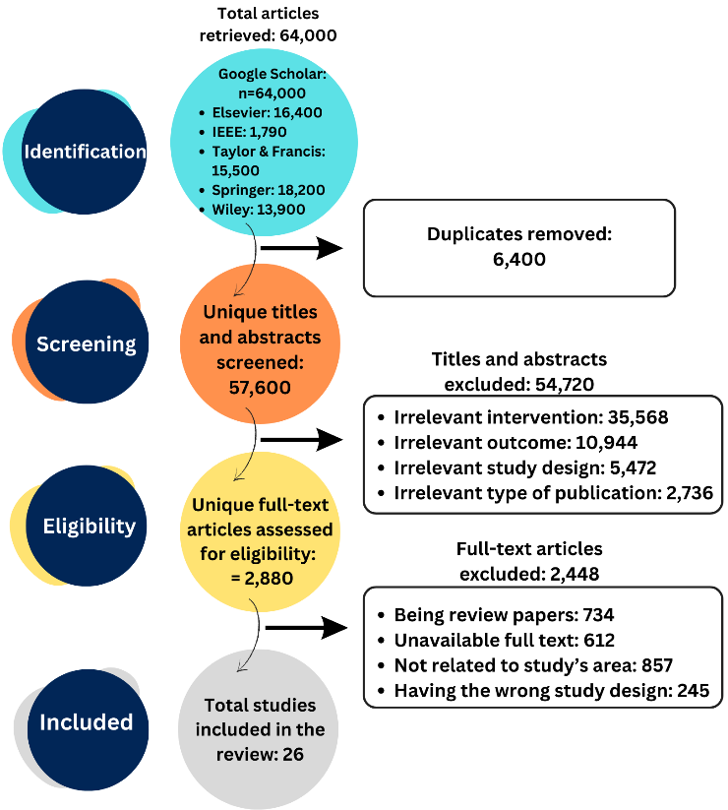

**FIGURE 1. Review Methodology**

The objective of this literature review was to analyse the implications of GIs on traditional products’ branding and economic performance, both before and after they were given a GI status. An example of the review methodology is shown in **FIGURE 1** The main focus was on primary research articles published from the year 2020 onwards which dwelt on GIs concerning development processes, implementation approaches, and traditional product implications. Additionally, we considered empirical studies that focused on law frameworks, economics benefits consumer behavior etc., about GIs. Therefore, scientific validity required that only peer-reviewed journals be included while non-empirical works; publication out of English did not deal with GI explication were avoided

**Review Method**

The review included publications such as previous works for historical setting and establishing framework. The following keywords were used in the search: GIs, typical products, GI branding, economic contribution of GIs, and countryside development using GIs.

**Inclusion Criteria**

The inclusion criteria for this review are:

* Studies that deal with the use of geographical indications for governing traditional products.
* Research that deals directly with GI regulatory models or policies on managing traditional products.
* Empirical studies showing data about economic consequences; changes in consumer behaviour; marketing strategy etc. associated with GI goods.

**Exclusion Criteria**

The exclusion criteria are:

* Research not touching upon any aspect related to application of GI in regulating and promoting traditional Commodities.
* Research that does not focus on applying GI frameworks to individual conventional products.
* Studies conducted outside the scope of GI regulations pertaining wider agricultural or cultural issues without specifically mentioning GIs.

**Quality Assessment**

To ensure the presence of outstanding scientific articles, used reliable resources like Google Scholar, Taylor & Francis, Springer, Elsevier or IEEE Xplore. At inception there were 64,000 documents from these sources. After dropping 6400 copies and was left with 57600 titles and abstracts that had to be reviewed. Of these 54720 did not relate to intervention outcome study design type publication and were thus excluded. Consequently another 2880 full-text articles were taken into account for eligibility criteria purposes or otherwise which resulted in a further exclusion of 2448 papers because they were review papers; unavailable full texts; area relevance absent; wrong study design employed etc. Finally our analysis included twenty six studies.

This is a very comprehensive process so as to select only relevant and high-quality materials that explain the influence of geographical indications (GIs) on traditional products’ brand building as well as economic performance. Such researches will aid in understanding how GIs can enhance sustainable rural development and community empowerment.

**REVIEW OF LITERATURE / RESULTS**

**How Have Geographical Indications (GIs) Changed over Time and What has Been Their Contribution towards Branding Traditional Products?**

**FIGURE 2** shows the changes and effects of Geographical Indications (GIs) along three major dimensions: Development & Framework, GI Systems Comparison, and GI Branding Success. In the Development & Framework part, the emphasis is on EU policy provisions, UNESCO’s goodwill, and the failures of product heritage protection. The GI Systems Comparison presents some cases of Brazil, Costa Rica, and Moldova where there is a clear difference in branding the territory. Finally, GI Branding Success covers the cases of Tuscany in Italy and Turkey and how they put GIs towards economic development as well as cultural identity sustenance. The fragmentation described above follows the order of the text which deepens the argument on the impact of GIs in transforming economies, laws, and branding in different parts of the globe.

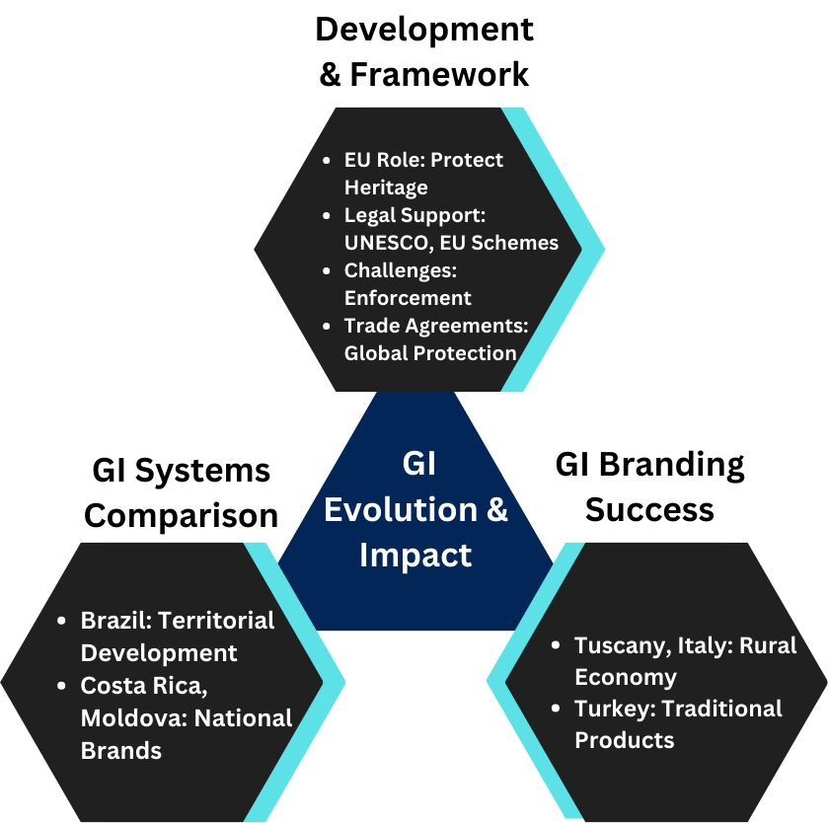

**FIGURE 2. Changes. and Effects of Geographical Indications (GIs)**

*Historical Development and Legal Framework of Geographical Indications*

Geographical indications (GIs) play a crucial role in the protection of intangible cultural heritage within the European Union (EU). This intersection of location-specific intellectual property rights and intangible cultural heritage safeguards idiosyncrasies and conventional methods of production. The establishment of GIs in the EU is rooted in both the UNESCO Convention for Safeguarding Intangible Cultural Heritage and EU Quality Schemes Regulation. However, these are inadequate as International misappropriation demands transnational measures which are encumbered by complexities including where should ICH be safeguarded? By who? How can it be done?. Therefore this analysis shows that through law-making, institutions and history we can see examples on how brands were built using GIs for protecting traditional goods before or after GI. [1]

Inclusion of geographical indications in its trade agreements has also enhanced their global role in promoting and protecting traditional products for the EU; this approach should be stronger. This means that trade should recognize different qualities with non-members just as UNESCO’s QSR does within member states. Besides, it also entails other implications like their recognition abroad being enforced outside union borders which shows wider consequences related to international commerce or even safeguarding culture globally through transnational channels not always respecting local sensitivities around ICH protection and so on dependently on how GIs evolve legally throughout the pre-gi period of brand building. [2]

*Case Studies of Successful GI Branding*

Protecting the geographical indications (GIs) can help the local producers distinguish their products in the market thus allowing them to avoid price competition and promoting fair competition among producers. An example is Tuscany, Italy, which was granted EU legal protection; this not only increased farmers’ incomes but also had significant economic and social effects at local level. This indicates that GIs have a crucial role to play towards rural development mostly in marginalized areas through raising awareness about products from such places as well as sustaining traditional knowledge and cultural heritage. As for Sorana Bean PGI, a few small-scale farms were able to effectively sell most of their production thereby resulting in increased socioeconomic activity within that particular area hence enhancing social cohesion too. Thus GI’s are more than one-sided, they are not only ‘good for businesses but also ‘good for nature’ as well as ‘good for culture.’ [3]

Moreover, Turkey has used GIs in marketing traditional products as well as promoting rural development although there is no concrete evidence or anything much being known. The legal framework for GIs was introduced in Turkey in 1995 which allowed producers to differentiate their products and take advantage of the reputation developed by GIs thereby increasing the incomes of local producers. This has been most helpful in underdeveloped rural areas where there are very few employment opportunities. Finally, one can see it on the example of GI-registration process combined with active marketing campaign, aimed at saving traditional products’ place both within national and international markets: Champagne, Cuban Cigars or Roquefort Cheese were registered as GIs what proved its high efficiency. In addition to this, it should be further noted that protecting Geographical Indications not only improved an economy but also contributed to avoiding migration from countryside into cities thus supporting general rural area development while preserving cultural heritage too. [4]

*Comparative Analysis of GI Systems across Different Regions*

In Brazil, the interplay of state laws and federal legislations alongside wider strategies for territorial-based development is captivatingly reflected by Geographical Indications (GIs). The Brazilian agrifood system is dual structured, with globalized agribusinesses existing alongside energetic family farming enterprises, hence GIs approach in this country. There are two different ministries responsible namely Ministry of Agriculture Livestock and Supply (MAPA) and Ministry of Agrarian Development (MDA). For instance, GIs registration is undertaken under the oversight of National Institute For Industrial Property(INPI) following TRIPs agreement guidelines; however, that cooperation which Europe had with some states has contributed significantly to the promotion of GIs benefiting mainly small scale farmers. The Brazilian experience clearly demonstrates how far such indications can go in developing territories while pointing out that there must be permanent adjustment and shared understanding that enables complete maximization of their potentiality. This analysis helps us understand further that depending on where we look or come from, there might be different approaches to GI’s thus leading into various outcomes in terms of institutional set ups as well economic impacts associated with them. [5]

Small developing countries like Costa Rica and Moldova can also serve to demonstrate the manner in which they have employed geographical indications (GIs) in building national brands and enhancing their export competitiveness. For instance, Tarrazú, known for its world famous high quality beans has succeeded in using GI system of Costa Rica to promote coffee production. The success is demonstrated through proper legislations and institutional set ups that create a distinction between local producers participating in the global markets such as the strength of the country’s GIs system. On another similar note, Moldova has also greatly benefited from geographical indications by associating its wine industry with Codru and Stefan Voda regions, making it popular among consumers worldwide with its unique brands. These undertakings have not only increased market visibility but also contributed towards rural development and cultural heritage preservation thus proving that indeed it takes more than just effective marketing tools underlined by international co-operation to build nation brands based on Geographical Indications within small developing countries such as Costa Rica & Moldova. [6]

**What is the difference between Pre and Post-GI Economic Benefits for Producers of Traditional Goods Under Consideration?**

**FIGURE 3** explains the economic advantages of Geographical Indications (GIs) by separating them into Economic Performance Indicators, Export and Market Access, and Longitudinal Case Studies. It also reveals the appreciation of land values and premium prices in GI registered regions, especially in China and Brazil. Furthermore, it illustrates the impact of GI certification on exports in Vietnam and the Australian-Indian wine trade, resulting in enhanced market accessibility and improved brand image. Finally, the image shows the GIs’ contribution to the enforcement of premium prices for origin bound brands (OBBs) while augmenting production in Vietnam, which solidifies the GIs’ long-term economic benefits.

.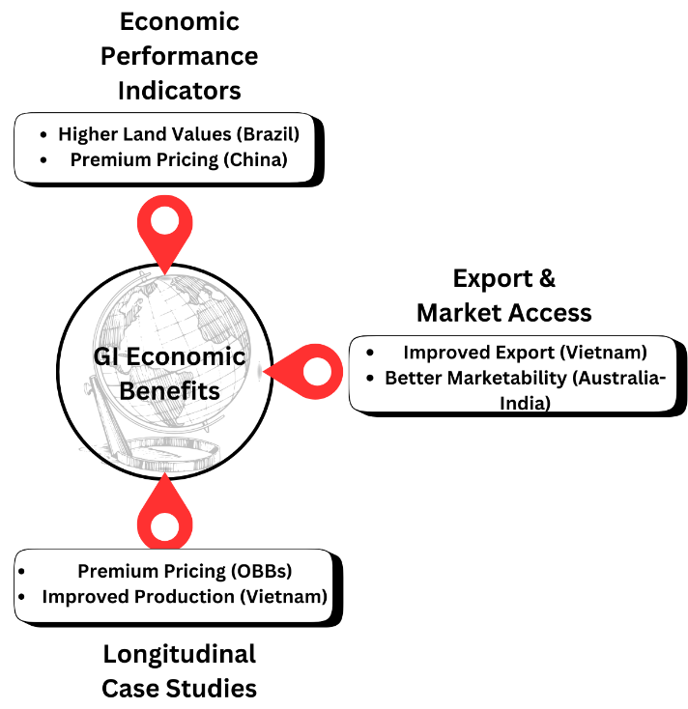

**FIGURE 3. Economic Advantages of Geographical Indications (GIs).**

*Economic Performance Indicators for GI Products*

Wine industry performance, for example, in the southern part of Brazil has greatly improved after the geographical indications (GIs) for high quality wines were set up. The appointment of “Vineyard Valley” as an origin has also led to increases in land values, widening of the area that is planted and enhancement of technological standards. These factors have resulted in a greater number of tourists coming to the region and higher levels of consumption as well as more diffused products. Additionally, this status has made the entry for wineries to the new hat is markets by means as it were to exportation which in turn enabled them to get international recognition and also resulted to bigger earnings from those sales. Taking into consideration all concerning the noted aspects, such as technological advancement, expansion of production areas in place or even increment of land prices, it is undeniable that GIs are capable of enhancing the economic viability and competitiveness of local wineries. [7]

Notably, an empirical study conducted on Taobao, the largest online marketplace in China has indicated that geographical indications (GIs) do have economic benefits for agricultural products. Such items which are not labelled with GI tags are priced cheaper than those with their origins identified. This is because people tend to think that things from such regions are of superior quality making them genuine. According to sales records analysis, tea, rice and other foodstuffs coming from recognized areas attract high price mark-ups thereby underscoring the potential added value that can accrue to traditional foods through GIs within particular countries like China where this survey was carried out [8]

*Impact on Export and Market Access*

Vietnam’s adoption of Geographical Indications has greatly helped in increasing agricultural exports and promoting market access. The government’s proactive approach to registering and protecting GIs like Luc Ngan lychee, Phu Quoc fish sauce or Moc Chau Shan Tuyet tea has led to their international recognition thus giving them credibility abroad too. This differentiation will allow higher prices for Vietnamese goods in the global market simply by indicating their origins using GIs. Moreover, these labels also serve as proof that one is buying genuine products since they show where products are made which reduces counterfeits risks as well as supports secure positions in export markets because people would rather buy something with well-known quality standards than an unknown brand name. [9]

Furthermore, as a part of the Australia-India Comprehensive Economic Cooperation Agreement, GIs for wine have been introduced and this has resulted into far-reaching effects on the potential export and market entry practices employed by individual producers. For example, different winemakers in Nashik Valley located in India or Barossa Valley which is situated in Australia have used them to differentiate their brands from others without such cultural background and history hence allowing them to make good use of these places’ unique features. This has created consumer trust and thus GI-labelled wines are considered more genuine than other types available thereby fetching higher prices upon purchase. The latter actually allows the wine to move beyond borders by reducing trading barriers and enabling people to access each other’s markets easily. In terms of economies, there are numerous benefits that include increased incomes through exportation, reaching out many clients and building maker’s brand value both within country and internationally thus demonstrating how much GIs can influence market expansion overseas for sellers. [10]

*Longitudinal Case Studies of Economic Impact*

Origin defined brands (OBBs) are products that gain unique financial rewards by being associated with a certain geographical indication. Wines are especial cases, their genuineness and background being attached to places makes them reputable brands. These items also called “place based” have become recognized as differentiable entities thus they can be priced highly just because people adore them. Furthermore this even makes it demand itself, notwithstanding frequent attempts of imitation by counterfeits as well. Additionally, premium pricing and brand loyalty among others such as differentiation are the economic indicators for OBBs but they still show that GIs play a crucial role in promoting these goods’ economic viability. [11]

Similarly, geographical indications have played a fundamental role in Vietnam when it comes to enhancing the quality standards and improving competitiveness of agricultural products in relation to their performance in international markets. These include such examples as Phu Quoc fish sauce, Luc Ngan lychee and Moc Chau Shan Tuyet tea whose premiums were enhanced by GI measures for better production quality controls and wider market openings that came with these GIs. What these GIs do is guarantee authenticity which allows small scale producers to differentiate themselves from other players within crowded markets, leading to high export volumes outside domestic borders hence farmers who are involved in these traditional agro-activities can achieve higher returns on investments over years. [9]

**Do Consumer Perceptions and Behaviours towards these items Change Once they get a Geographical Indication Tag?**

**FIGURE 4** illustrates the perceptions of consumers on post-geographical indication (GI) certified products; it divides them into three main sections of: Awareness & Understanding, Quality & Authenticity and Buying Behaviour Post-GI. The author argues that knowledge about place-based product quality has been enhanced via gustatory senses such as those possessed by Turkey. In contrast with others in here, Quality & Authenticity focus on scientific evidence (metabolomics) and price attributes of Darjeeling tea. Regarding buying behaviour post-GI, there is a case for marketing foreign GIs to develop customer confidence and influence their purchasing decisions hence fostering local confidence in products from the same origin. This holistic view emphasizes how GIs impact on consumer perceptions and conduct.

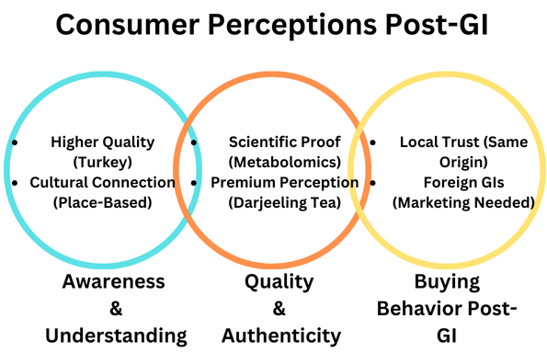

**FIGURE 4. Consumer perceptions and behaviours post-GI certification.**

*Consumer Awareness and Understanding of GIs*

The recognition and understanding of geographical indications is one of the influence on consumerism. According to studies, consumers prefer GI-labelled products from their localities because they believe that such are a better quality and more authentic than other non-local ones. In, for instance, the case of Izmir Turkey purchasing behaviour study; South Aegean Olive Oil was selected instead of Ayvalik Olive Oil which does not exist in its locality among others. This decision is influenced by factors such as quality, origin and packaging. Apart from trust and value for money associated with these products, buyers were willing to pay more just for purposes of promoting their locality hence demonstrating trust due to proximity to home also impacting on how safe they perceive these items. [12]

The extent to which consumers participate in the life of their locality has a great impact on their geographical indication knowledge. People who have strong affiliation with their place of birth are more likely to hold dear such kind of goods where they see them as expressions of native cultures or histories. This is, therefore, not only one way that people can learn about GIs but also an aspect that strengthens trust for such commodities through emotional links built between places associated with units engaged in production activities situated in regions known for specific brand names/services marketed across the globe thus positioning them as unique marketing tools often used during international business transactions. Researchers have shown that individuals with high place attachment often help local economies by purchasing products marked under GIs because these things supposedly signify better qualities and also stand out as genuine ones. [13]

*Perceived Quality and Authenticity of GI Products*

The use of metabolomics to market products with geographical indication is helpful because it offers a scientific way to verify the authenticity of these items and promote their distinctiveness. Metabolomics refers to the analysis of chemical fingerprints produced by plants so as to associate specific features with where they were grown. The purpose of doing this is to ascertain whether or not something labelled under GI is at par with its expected standard of quality thus, reinforcing peoples’ belief on superiority over others that are considered more unique. Moreover, by providing tangible evidence linking produce with terroir; metabolomics creates better consumer awareness hence may appeal to people who require some form of security before buying such things as well as acts as a legal protection against counterfeiting or misbranding incidences involving GIs. [14]

Darjeeling tea, a global example of GIs, is perceived as genuine and high quality because of its terroir and labor practices in various tea estates where it is produced. In other words, the marketing of Darjeeling tea should consider the environmental conditions surrounding the plantations referred to as ‘terroir’. The Tea Board of India and the Darjeeling Tea Association have marketed Darjeeling tea as one of the most renowned Geographic Indication (GI) products like Champagne and Cognac by focusing on its distinctiveness in terms of geographical location and experienced workforce. Marketing materials discuss how local women’s hands pick up leaves from the tea bushes so that they literally “craft” them. This representation increases both its value and authentic Darjeeling tea which satisfies customers’ desire for opulence and traditionality when making purchases. For this reason, correct labour or terroir marketing is necessary to maintain top positions in the market as well as high market prices for such kind of teas since it implies that there will always be someone willing to pay more for it just to get his/her cup filled with this beverage. [15]

*Changes in Consumer Buying Behaviour Post-GI*

The impact on consumers of geographical indications (GIs), is particularly pronounced upon individuals with strong brand loyalty to products because of their source. According to a study, consumers show more trust when they are located in the same area as those goods. This confidence comes from a sense of authenticity created by GIs focus on qualitative distinction strategies. Familiarity with local items and their cultural value strengthens commitment among them which ultimately results in higher willingness to pay premiums post GI approval and this can be seen through changes in people’s purchasing behaviour following such an event. With the availability of two possibilities, customers switch to buying ‘GI’ labelled ones instead of non-GI alternatives revealing that origin becomes important in choice making between these two options. [16]

Moreover, insights on post-GI consumer behaviour can be obtained from the perspective of gatekeepers in respect to foreign GIs. In most cases, however, consumers have been seen to identify with authenticities attributed to them but this finds its best ground on common local brands. Therefore, global GI brands will need a lot of information dissemination if they are to attain equal recognition with all people at large. The gatekeepers noted some interest among buyers towards such items after this period; yet, there was still caution due to extra value that is added by their quality standards guaranteed by GI’s. Nonetheless, only being a GI cannot be enough, it should go hand in hand with consistence in terms of quality control measures , traceability systems as well as strong promotional strategies so that customers can readily link them to place-specific origins Post- gi consumer behaviour change indicates willingness accept new GI’S when they meet high standards required by customers with regards these products’ superior storytelling capabilities linking them back authoritatively into their respective geographical and cultural backdrops. The above shift also demonstrates the potential effectiveness of facilitating market access while ensuring trust between end-users if applied properly. [17]

How effective is geo-marketing when applied in areas inhabited by the us population where the traditional goods may or may not hold marketing significance?

**FIGURE 5** illustrates some of the challenges and new opportunities that come with getting/ retaining a Geographical Indication (GI) status are shown. It split them into three key areas; Economic and Logistical Barriers, Regulatory and Legal Challenges, Opportunities for Rural Development. The regulatory difficulties the writer discuss briefly in India include enforcement issues and high standards demanded by the wine industry. Marketing costs for New Zealand’s wine industries, traditional products logistical bottlenecks faced by Australia’s wines industry in Turkey .Opportunities for Rural Development comprise increased marketability as well as incomes, tradition preservation for Vietnam; Australia/India have tourist attractions while GI status bring about economic growth. This means that countries like Vietnam could really benefit if these articles were allowed to be sold outside their borders.

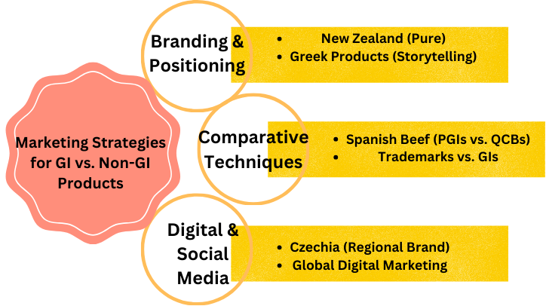

**FIGURE 5. Challenges and opportunities in obtaining/maintaining GI status.**

*Branding and Positioning Strategies for GI Products*

The campaign 100% Pure New Zealand is an illustration of how branding and positioning can enhance global profile. In 1999, the program was meant to exhibit the unique landscapes, culture and tourism activities in New Zealand. It therefore created a personality for the brand that was compelling as well as emotionally appealing which was driven by Purity and natural beauty. To achieve this, the campaign focused on key markets such as: Australia, Japan, USA, UK, Germany Singapore amongst others thus positioning New Zealand as a niche travel destination. During this period there were a lot of researches conducted in marketing complemented by establishment of strategic alliances that played a major role in ensuring that NZ had strong global competitive identity within the tourism industry. Another important aspect to note about ‘100% pure new Zealand’ is that consistent messages delivered over long hauls has been resulted in stronger brand recognition thus making it work well as a branding effort. [18]

The Greek territorial products with geographical indications (GIs) have also benefited greatly from the use of branding and positioning strategies. For example, Kalamata olives or feta cheese have managed to dominate their respective markets by narrating how they are made in a traditional way using protected GI’s regulations while at the same time emphasizing this story as a differentiating factor globally as well as bringing out issues on authenticity, quality, and cultural heritage etcetera so that storytelling became part of those campaigns that would link each product back to its geographic roots by making consumers appreciate them much more for what it meant since they could feel owning / participating something unique only known few select individuals who do value but is highly regarded amongst . Furthermore, when combined with GIs, branding strategies have allowed Greek producers to charge higher prices thereby ensuring steady custom base as well increasing economic growth through rural development preservation local customs improved performance. [19]

*Comparative Analysis of Marketing Techniques for GI vs. Non-GI Products*

Two methods of product differentiation are employed by the Spanish beef industry. These are Protected Geographical Indications (PGIs) and Quality Certified Brands (QCBs). PGIs associate products with specific places as well as traditional approaches used in their production thus making them more authentic to buyers while QCBs focus on consistency in quality management measures including non-geographical labelling. In this regard, it is evident that storytelling about heritage regions and observance of conventional methods during production becomes important when marketing PGI related goods for people who want to have real cultural experience based on tradition unlike QCB which is more about maintaining a certain level of safety in all communication around its products if it must be widely accepted by consumers and should therefore reflect the priorities of certification where different markets are being targeted at the same time. This comparison indicates that PGIs exploit geographical cultural aspects to create a niche market for a given locality/area with an assortment of brands in those jurisdictions but QCBs focus on global norms universally applicable across all markets differentiating them notwithstanding their places of origin which must contain certain basic features necessary for gaining the confidence of any customer abroad the country concerned that it is not produced within. Furthermore, standard trademarks vary considerably from GIs in terms of how they are used to market and brand products.[20]

Standard trademarks are usually used to maintain brand identity and relative uniformity by ensuring that a given product is thought to have some specific qualities regardless of where it is made. This method tends to be employed widely in industries which call for conformity and wide market coverage. Conversely, Geographical Indications (GIs) concentrate on the distinctiveness emanating from certain geography such as environmental factors, traditions among others that also contribute to their cultural heritage. The method is appealing to consumers who are seeking freshness or a sense of connection with the source of a product. Generally, marketing strategies by normal brands encompass mass advertising, extensive distribution networks and loyalty programs that are designed to create strong brands while GIs tend to tell stories about how items were traditionally made by artisans supported via various marketing communications activities such as events targeting niche markets etcetera yet reveal its history through an origin story which might incorporate focused campaign so as to accomplish this effectively. Thus, comparative analysis done shows clearly that standard trademarks gain market share through maintaining their promises worldwide in every corner while GIs add value by leveraging unique features combined with cultural resonance tied up with territorial goods therefore attracting other consumers who value authenticity and provenance. [21]

*Role of Digital and Social Media in Promoting GI Products*

In Czechia digital platforms have largely contributed to the rise of geographical indication (GI) products from a culinary tourism perspective. The central objective behind “Regional Brand” campaign which relies on digital platforms is to make regional food products more visible. To establish direct relationships with global consumers, social media campaigns are accompanied by interactive websites and online marketing strategies designed specifically for regional brands. Furthermore these tools enable suppliers share stories about their own commodities, acknowledge traditional recipes or even show how different each product is from others .As a result of such changes in marketing strategy this will allow them to take place along with other things like social media that can be used as means through which manufacturers could communicate directly with buyers outside their premises including the aforementioned aspects .This way ,the producer can reach more people via social media alone thereby creating a sense of belongingness around these locality-specific goods .Thus these items are today known by many more persons than ever before hence they are also highly demanded; this has improved general image of Czech culinary gifts too. [22]

The importance of using digital and social media platforms to promote GI products is increasing because they can target particular audiences and offer a variety of ways to engage. Global consumers are aware that geographical indications are real, old-fashioned and high quality type through tools such as content creation, influencer relationships or even placing adverts on Facebook. Through using data analysis techniques combined with conducting market surveys breeders can develop tailor made ads that resonate well with specific groups who may become potential advocates for such commodities. In addition, social media provides an avenue for customers to give their opinions about particular brands so as to enable businesses make better decisions. For instance, there has been a considerable increase in sales volumes visibility in different markets and consumer confidence towards GI products as shown by how much influence these devices have had on modern branding campaigns. [23]

**What are some difficulties Experienced by Manufacturers during Acquisition as well as Maintenance of Geographical Identification Statuses for their Respective Ancient Commodities?**

**FIGURE 6** depicts the barriers and possibilities related to acquiring and sustaining Geographical Indication (GI) status for various regions. It captures Indian regulatory challenges where enforcing problematic and strict industry norms make GI adoption complicated. Also, economic and logistical challenges like Australia & New Zealand’s high costs and rural logistics problems in Turkey make it more difficult. Still, GIs offer prospects of rural development, for example, in Vietnam or the Australia-India wine industry. The figure reinforces the idea that GIs have an impact on economic sustainability, market access, and community empowerment in different parts of the world.

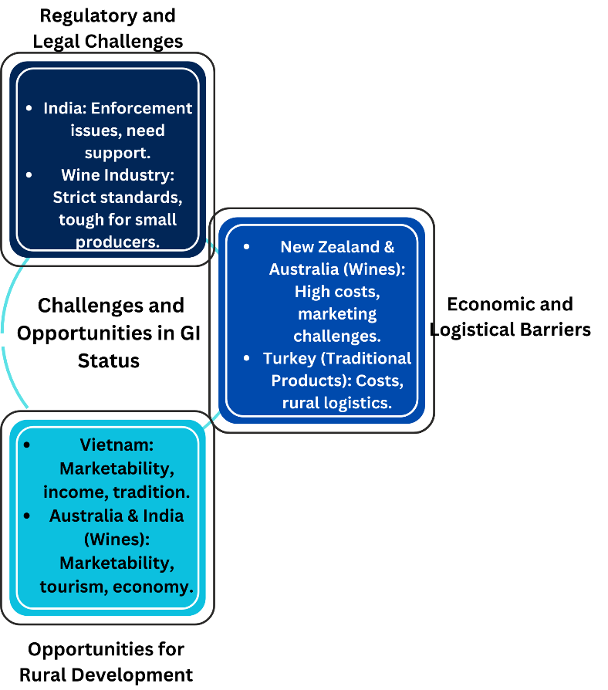

**FIGURE 6. Marketing strategies for GI vs non-GI products.**

*Regulatory and Legal Challenges in Achieving GI Status*

Achieving Geographical Indication (GI) status anywhere in the world, including India, has always been a hurdle of regulatory and legal issues. The GI Act 1999 and Geographical Indications of Goods (Registration & Protection) Rules 2002 created a sui generis system to protect GIs. However, there have been associated problems with enforcement such as ensuring that the benefits of such rights reach the actual producers and artisans at the bottom end of supply chains. For effective enforcement both locally and globally, available resources are required by stakeholders who may not have them especially from developing countries. In addition, equitable sharing of economic benefits coming from GIs necessitates proper institutional mechanisms which take into account marketing aspects; promotion activities; and rights protection relating to GIs that are vital for unleashing huge potential benefits locked up in them. [24]

Obtaining and maintaining GI status in such industries, as well as others, entails grappling with complex regulatory frameworks. For example, various operations may need to join trade associations while others also influence their production trends, which if regional branding is to be accepted in the wine industry. The regulations governing the formation of geographical indications like AVAs are very strict when it comes to things like boundaries marking out; grape sourcing among other conditions like production quality must be highly followed thus implying that GIs are unique but difficult standards for some winemakers who may fail to adhere due lack of enough capital base or expertise Compliance can become a burden especially for new entrants into market without sufficient resources and weak institutional arrangements even though this strategy has many marketing benefits; however there still exist legal barriers that have to be overcome particularly at those points where industries are budding. [25]

*Economic and Logistical Barriers to Maintaining GI Status*

The geographical indication status of wines from New Zealand and Australia is difficult to keep due to many logistical challenges. To clarify, there are strict regulations in both countries that dictate how wines must be labelled. Sometimes the small wine producers do not qualify for this because they do not have sufficient funds for meeting all the required quality control standards and other criteria that can help them obtain such a status mainly because they are financially incapacitated. Moreover, global market dynamics demand that marketing efforts should always be on course so as to keep pace with consumer perception about any premium nature connected with this type of product. This is made worse by the intense competition within the wine industry, which makes it difficult to balance between GI position and profitability due to higher production costs involved in achieving such positions. However, if resources are limited, differentiation becomes difficult leading to a compromise on quality so that expenses are reduced. Nevertheless, it is correct that regardless of many problems experienced along supply chains ranging from tracing back origins up until final destination points coupled with verifying authenticity related claims made concerning geographical origin(s), success achieved in terms obtaining higher prices as well gaining wider recognition can push any producer through these barriers thus more income generated from sales. [26]

On the other hand, protecting GI status for traditional products in Turkey is challenging due to economic and logistic reasons that might pose threats to sustainability of the same. Some of these include; registration process fees, continuous compliance with quality requirements as well as marketing efforts aimed at distinguishing GI products in competitive markets. It is necessary for producers to ensure that their goods are excellent and maintain prestige by using quality control mechanisms and engaging in promotions. Also, this process can prove logistically tough when it comes to verifying geographical origin or checking if production methods comply with GI standards which may take many resources. In rural areas these challenges become more difficult due to limited infrastructure and other resources such as personnel or funds. However this notwithstanding, they still continue because there is a chance of getting more money through market niches thus they utilize GI status into their economic enhancement strategies while promoting rural development at large. [4]

*Opportunities for Rural Development and Community Empowerment*

One of Vietnam’s greatest tools for promoting rural development and empowering local communities is the use of geographical indications (GIs). The proactive stance taken by the government on GIs has improved the quality control systems, which have in turn enhanced marketability levels of some local agricultural products such as Phu Quoc fish sauce, Luc Ngan lychee, Moc Chau Shan Tuyet tea, etc. Also, brand building was done simultaneously with an establishment and enforcement of reputation enhancing authentication that ensures income growth for farmers who produce these commodities while preserving traditional production techniques to date. Collective management in GI areas also strengthens communities through cooperative ventures hence taking part and sharing gains realized from such investments. This shields them against economic shocks emanating from lack of stability within individual businesses thereby offering alternative sources for incomes locally propelling sustainable village level growth without moving to other areas. [9]

The Australia-India Comprehensive Economic Cooperation Agreement gave rise to wine GIs that offered numerous opportunities for rural development and community empowerment in both countries. Therefore, to increase sales volumes as well as profit margins; that is when it comes to such places as Barossa Valley or Nashik Valley other than others, wine producers can avail themselves of the unique features associated with particular locations so as to attract more consumers. As a result, tourism is boosted hence leading to higher prices paid for GI labelled wines in those areas but this at the same time helps retain viticulture traditions across all parts of the globe not only Australia alone because even other parts world may benefit from these kinds activities too. Additionally, any infrastructural development projects put up thus creating more jobs especially within rural based regions have ripple effects on the economy beyond just the wine industry. [10]

**FINDINGS FROM RESEARCH**

**Evolution and Role of Geographical Indications in Branding**

Previous works have accurately envisaged most of the components of GIs in EU. Branding and protecting traditional products through GIs has greatly facilitated the establishment and enforcement process. According to some research, the EU’s legal frameworks for GIs consist of standard rules that provide product origin and authenticity protection which is also mentioned in scholarly writings on comprehensive GI regimes provided required by these laws based on earlier predictions concerning GIs’ role in preserving cultural heritage as well as maintaining product quality.

“GIs are used to protect names that identify specific goods because they possess special characteristics attributable only to their place origins coupled with traditional know-how” (EU Regulation No 1151/2012, Art 1).

**Economic Benefits Pre-Post GI Status**

Economically, the benefits realized upon gaining GI status for traditional products are similar to what was previously mentioned, as various academics had been looking at the matter from different viewpoints. This has led to some goods being valued more highly in terms of their uniqueness through geographical indications labels thus increasing their worth even more when they get exported. There are cases where southern Brazil nuts and Chinese tea leaves were discovered sold better with GI tags due to believe that buyers had about them being original thus reliable hence this also goes to prove that again the economic merits behind such mechanisms for typical goods makers’ wallets One thing however is clear from this argument all along – consumers valued knowing where food or drink came from so as to keep healthy and back local farmers.

“By allowing those products meet defined standards, GIs ensure a premium price through them enabling sale under reserved designations” (EU Regulation No 1151/2012, Art 13).

**Changes in Consumer Buying Behaviour Post-GI**

In present times, the arrival of GIs’ have led to shifts in consumer behaviour mainly among those who prioritize genuineness and their immediate environment. It signifies that as far as other products marked this way are concerned; they would go for it because they think that its quality is superior to others from different places which are associated with specific geographical locations where different surveys have been done on what were discussed earlier about effects on people’s buying behaviours. This change therefore highlights how much the origin can influence customer choices whilst enhancing visibility in traditional goods.

“Such individuals perceive guaranteed products to be genuine and hence willingly pay a premium for them” (EU Regulation No 1151/2012, Art 7).

**Marketing Strategies for GI Products**

Earlier works have long anticipated the fact that employing winning commercial approaches on GI products are crucial to their success. This is why some brands do better than others in places with many similar items being sold side by side each other without any differentiation since they managed to create distinctive identities through GIs branding approach hence allowing them stand out among competitors, e.g., “100% Pure New Zealand” campaigns or Greek Kalamata olives and feta cheese May be such cultural heritage sites can be used for these types of food and drinks as well and this point was highlighted in one of their advertisements. This ties in well with previous academic debates about the need for strong marketing strategies when dealing with GIs so as to get more out of them.

“Advertising thus pays attention to peculiarities referring back to traditional values underlying cultural legacies or even particular characteristics which are specific to a territory.” (EU Regulation No 1151/2012, Art 12).

**Problems and Prospects of GI Regulation**

Despite the many positive aspects of GIs, there are some problems relating to how they are put in place and maintained. Some things are challenges that include; observance of stringent requirements as well as facing economic or logistical barriers by small-scale producers. On top of this, it was therefore concluded necessary establishing more encompassing frameworks which would address wider category traditional products taking into account sustainable development notion. These challenges confirm prior academic predictions on the complexity and limitations of GI regulations meaning that systems based on geographical indications will continuously improve while removing all obstacles.

“The management should ensure that rules are followed and assist businesses overcome financial restrictions linked with meeting them” (EU Regulation No 1151/2012, Article 15).

**POSSIBLE GAPS**

**Social and Ethical Considerations**

GIs are efficient at conserving cultural identity and promoting the customary goods, but fail to address social justice concerns of just trade. They secure market access and economic gains that may sidestep imbalances of power in maker economies. Thus, an all-encompassing approach is necessary to ensure a fair share for every stakeholder involved in GI protection process, particularly small-scale farmers or artisans.

“The protection of GIs should ensure equitable distribution of benefits between all those who produce them.”

**Enforcement and Compliance**

GI rules have a problem when it comes to application uniformly across regions that differ so much in between themselves, which is also applicable to different categories/types of producers of goods. For small scale manufacturers, the strict criteria set for registration under geographical indication terms are difficult to meet because such requirements imply having quality control systems and traceability measures that might be unaffordable or otherwise by them. Consequently, there should be structures for support put in place so as to enable them navigate through this regulatory framework while still maintaining their GI status effectively.

"GI regulations require regular audits in order to ensure compliance with quality standards."

**Need for Wider Inclusivity**

The current system could be bettered by broadening the scope of its operation so that together with the low profile ones, other things can also be protected such as lesser known traditional products which are in need of strong support for them to survive possible extinction and realize their full market potential through promotion; this is also part of efforts to protect further cultural diversity from loss whereby sustainability considerations might be included in any use related rules for such items where appropriate certain traditional production methods should therefore be adjusted as well and encompassed within existing legal frameworks governing this area while applicable legislations must embody these principles aimed at achieving requisite outcomes thus advocating sustainable approaches would also help meet ecological needs yet promoting rural development.

"The GI framework should cover more types of traditional products and take into account ecological factors associated with their creation."

**Specific EU GI Regulation Gaps**

The EU GI regulation is robust; however, it has some weak points. The first problem is that it does not have too much flexibility in its legal shape to accommodate different cultural contexts. Secondly the legislation seems to concentrate predominantly on popular items hence excluding those which are not well known but also deserve protection, and thirdly; Small scale producers may require more support for them to meet the standards set by regulators since compliance requirements can be so demanding.

EU legislation on GIs recognizes, transparency, accountability and fairness as being human rights (EU GI Regulation Article 13)

According to scholars, the present geographical indications system e.g. EU one corresponds to expectations about culture and economics. However, a lot more will have to be done in order to come up with a global comprehensive scheme around GIs that is strong enough for everyone involved. It is essential that all stakeholders especially producers themselves government must work together more closely therefore they should improve the existing regulations make it fairer as well support them being implemented across different regions wider protections traditional knowledge systems this path would achieve greatest possible gains sustainable development empowerment rural communities through creation vibrant markets based on locally produced goods services thereby stimulating growth inclusive globally competitive economies while safeguarding against negative impacts brought by reduction in diversity among others too numerous mention here.

"The regulatory framework aims at striking balance between economic gains and cultural environmental protection measures."

**CONCLUSION**

**Summary of Main Findings**

This research aims to uncover the history, advantages and selling strategies of geographical indicators (GIs) with regard to their effect on traditional products’ branding before and after they get recognition as GIs. Research reveals that GIs tend to have firm legal frameworks, which are uneven in their application among different regions. Several cases have shown various benefits of GIs like economic profits, cultural heritage conservation and marketable gains. Moreover, the article emphasizes that rural progress is made through GIs as well as empowering communities; it identifies major macroeconomic factors arising from expanded export opportunities linked to GI merchandise due to shifts in consumer preferences.

**Significance and Implications**

The consequences of these findings are significant to policy makers, manufacturers and advertisers concerned with the promotion of customary goods. The findings indicate how important GIs are for improving market positioning as well as economic viability of traditional products. By intersecting theoretical frameworks with practical outcomes, this survey can provide beneficial insights into determining when do GIs work best for rural development or cultural heritage conservation? These results would enable policymakers to formulate more elastic and adaptable geographical indication regulations that promote economic growth while conserving cultural diversity. Policymakers have to guarantee robust legal protection on GI’s so that effective marketing strategies can benefit the producers of traditional goods maximally.

**Limitations**

Firstly, the study was limited by focusing only on high profile products of geographical indications, thereby excluding all other traditional ones found across the globe.. Secondly most cases were selected from particular areas thus failing to recognize different settings where same things may be happening.. Again, this approach means a wide range of laws in various parts of the globe are overly dependent on ignoring cultural differences.

**Future Research Directions**

Future researchers should also evaluate how well GIs are operationalized under existing regulatory frameworks using empirical methods especially with regard to popular items and even less known varieties amongst them. This will give an insight into how such regulations affect different classes of goods with respect to economic advantages and cultural worth .. How does innovation in start-up SMEs balance dynamicity within small scale business intermediated by GI rules? Finally, we must mention international cooperation on regulatory agreements for uniform governance with respect to GIs worldwide.

**Further Thoughts**

In conclusion, the main argument of this research has been that for a well-functioning geographical indications regime to be put in place, it is necessary to have both theoretical and empirical grounds. Therefore, lawmakers need to come up with ethical legislation that can adapt to new technologies as well as shifting markets while weighing the gains against the accountability transparency guiding society tradition in making traditional products and such standards need sometimes necessitate a review of these kinds frameworks in order they promptly respond emerging threats sustainable development usually global fashion.

**ACKNOWLEDGEMNETS**

This study is supported by a student research grant obtained from RV University.   
Several AI tools were used for completing this research. Quill bolt was used for paraphrasing, Grammarly for grammar correction and sentence flow correction, and Turnitin to check for instances of similarity.

**REFERENCE**

| [1] | B. Ubertazzi, “EU Geographical Indications and Intangible Cultural Heritage.,” *IIC-International Review of Intellectual Property and Competition Law,* vol. 48, pp. 562-587, 2017. |
| --- | --- |
| [2] | T. Engelhardt, “Geographical Indications Under Recent EU Trade Agreements.,” *IIC-International Review Of Intellectual Property and Competition Law,* vol. 46, pp. 781-818, 2015. |
| [3] | G. M. A. B. A. Belletti, “Old World Case Study: The Role of Protected Geographical Indications to Foster Rural Development Dynamics: The Case of Sorana Bean PGI.,” *The Importance of Place: Geographical Indications as a Tool for Local and Regional Development.,* vol. 58, pp. 253-276, 2017. |
| [4] | U. G. Bilge Dogan a, “Geographical Indications: The Aspects of Rural Development and Marketing Through the Traditional Products,” *Procedia-Social and Behavioral Sciences,* vol. 62, pp. 761-765, 2012. |
| [5] | J. C. C. Wilkinson, “A Brazilian Perspective on Geographical Indications.,” *Territorial Governance,* pp. 143-158, 2011. |
| [6] | M. C. F. Florek, “Export flagships in branding small developing countries:The Cases of Costa Rica and Moldova,” *Place Branding and Public Diplomacy ,* vol. 3, pp. 53-72, 2007. |
| [7] | P. P. A. S. T. e. a. de Mattos Fagundes, “Geographical indication as a market orientation strategy: An analysis of producers of high-quality wines in Southern Brazil.,” *J Database Mark Cust Strategy Management,* vol. 19, pp. 163-178, 2012. |
| [8] | X. Li, “The impact of place-of-origin on price premium for agricultural products: empirical evidence from Taobao.com.,” *Electronic Commerce Research,* vol. 22, pp. 561-584, 2022. |
| [9] | G. &. N. T. T. Hoang, “Geographical indications and quality promotion of agricultural products in Vietnam: an analysis of government roles,” *Development in Practice,* vol. 30(4), pp. 513-522, 2020. |
| [10] | S. T. M. Taylor, “The Aroma of Opportunity: The Potential of Wine Geographical Indications in the Australia-India Comprehensive Economic Cooperation Agreement.,” *The Importance of Place: Geographical Indications as a Tool for Local and Regional Development. Ius Gentium: Comparative Perspectives on Law and Justice,* vol. 58, pp. 81-107, 2020. |
| [11] | N. Spielmann, “Brand equity for origin-bounded brands.,” *Journal of Brand Management,* vol. 21, pp. 189-201, 2014. |
| [12] | Z. M. K. &. T. E. Albayram, “Purchasing local and non-local products labeled with geographical indications (GIs).,” *Operational Research,* vol. 14, pp. 237-251, 2014. |
| [13] | Q. L. X. C. W. S. X. &. Y. R. Li, “Involvement, place attachment, and environmentally responsible behaviour connected with geographical indication products.,” *Tourism Geographies,* vol. 25(1), pp. 44-71, 2020. |
| [14] | A. M. d. M. E. G. J. e. a. A.L.L., “Metabolomics as a marketing tool for geographical indication products: a literature review.,” *European Food Research and Technology,* vol. 247, pp. 2143-2159, 2021. |
| [15] | S. Besky, “The labor of terroir and the terroir of labor: Geographical Indication and Darjeeling tea plantations,” *Agriculture and Human Values,* vol. 31, pp. 83-96, 2014. |
| [16] | L. D. V. G. B. S. &. D. M. Panzone, “When Consumers and Products Come From the Same Place: Preferences and WTP for Geographical Indication Differ Across Regional Identity Groups.,” *Journal of International Food & Agribusiness Marketing,,* vol. 28(3), pp. 286-313, 2016. |
| [17] | R. C. M. H. R. &. A. D. Wongprawmas, “Gatekeepers’ Perceptions of Thai Geographical Indication Products in Europe.,” *Journal of International Food & Agribusiness Marketing,,* vol. 24(3), pp. 185-200, 2012. |
| [18] | N. P. A. &. P. R. Morgan, “New Zealand, 100% Pure. The creation of a powerful niche destination brand.,” *Journal of Brand Management,* vol. 9, pp. 335-354, 2002. |
| [19] | G. &. S. A. Philippidis, “Territorial Product Associations in Greece: The Case of Olive Oil.,” *Journal of International Food & Agribusiness Marketing,,* vol. 14(1), pp. 25-46, 2003. |
| [20] | I. B. I. &. G. M. R. Atance, “Product Differentiation in the Spanish Beef Industry.,” *Journal of International Food & Agribusiness Marketing,,* vol. 16(2), pp. 123-143, 2004. |
| [21] | K. N. William Van Caenegem, “Standard trade marks, geographical indications and provenance branding in Australia: What we can learn from King Island,” *The Journal of World Intellectual Property,* vol. 23, pp. 632-657, 2020. |
| [22] | J. &. F. D. Spilková, “Culinary Tourism Packages and Regional Brands in Czechia,” *Tourism Geographies,* vol. 15(2), pp. 177-197, 2012. |
| [23] | B. G.-A. F. &. C. P. Urbano, “Market Research for the Optimization of the Consumers Response to the Recent Award of a Protected Geographical Indication to a Local Product, Beans from “La Bañeza-León” (Spain).,” *Journal of International Food & Agribusiness Marketing,* vol. 20(2), pp. 7-32, 2008. |
| [24] | K. Das, “Prospects and Challenges of Geographical Indications in India,” *The Journal of World Intellectual Property,* vol. 13, no. 2, pp. 148-201, 2010. |
| [25] | A. &. D.-P. A. Patel-Campillo, “Why types of operations, trade associations, and production trends matter in the geographic branding of an emerging industry.,” *Journal of Wine Research,* vol. 27(3), pp. 242-256, 106. |
| [26] | G. K. S. L. N. &. S. S. Banks, “Place ‘From One Glance’: the use of place in the marketing of New Zealand and Australian wines.,” *Australian Geographer,* vol. 38(1), pp. 15-35, 2007. |